***Chemistry***

**12: Kinetics**

**12.5: Collision Theory**

51. Chemical reactions occur when reactants collide. What are two factors that may prevent a collision from producing a chemical reaction?

Solution

The reactants either may be moving too slowly to have enough kinetic energy to exceed the activation energy for the reaction, or the orientation of the molecules when they collide may prevent the reaction from occurring.

53. What is the activation energy of a reaction, and how is this energy related to the activated complex of the reaction?

Solution

The activation energy is the minimum amount of energy necessary to form the activated complex in a reaction. It is usually expressed as the energy necessary to form one mole of activated complex.

55. Describe how graphical methods can be used to determine the activation energy of a reaction from a series of data that includes the rate of reaction at varying temperatures.

Solution

After finding *k* at several different temperatures, a plot of ln *k* versus $\frac{1}{T}$ gives a straight line with the slope , from which *E*a may be determined.

57. The rate of a certain reaction doubles for every 10 °C rise in temperature.

(a) How much faster does the reaction proceed at 45 °C than at 25 °C?

(b) How much faster does the reaction proceed at 95 °C than at 25 °C?

Solution

(a) The rate doubles for each 10 °C rise in temperature; 45 °C is a 20 °C increases over 25 °C. Thus, the rate doubles two times, or 22 (rate at 25 °C) = 4-times faster. (b) 95 °C is a 70 °C increases over 25 °C. Thus the rate doubles seven times, or 27 (rate at 25 °C) = 128-times faster.

59. The rate constant at 325 °C for the decomposition reaction  is 6.1  10−8 s−1, and the activation energy is 261 kJ per mole of C4H8. Determine the frequency factor for the reaction.

Solution

The rate constant *k* is related to the activation energy *E*a by a relationship known as the Arrhenius equation. Its form is:



where *A* is the frequency factor. Using the data provided, and converting kilojoules to joules:





61. An elevated level of the enzyme alkaline phosphatase (ALP) in human serum is an indication of possible liver or bone disorder. The level of serum ALP is so low that it is very difficult to measure directly. However, ALP catalyzes a number of reactions, and its relative concentration can be determined by measuring the rate of one of these reactions under controlled conditions. One such reaction is the conversion of p-nitrophenyl phosphate (PNPP) to p-nitrophenoxide ion (PNP) and phosphate ion. Control of temperature during the test is very important; the rate of the reaction increases 1.47 times if the temperature changes from 30 °C to 37 °C. What is the activation energy for the ALP–catalyzed conversion of PNPP to PNP and phosphate?

Solution

Note that . Changes in rate brought about by temperature changes are governed by the Arrhenius equation: . In this particular reaction, *k* increases by 1.47 as *T* changes from 30 °C (303 K). The Arrhenius equation may be solved for *A* under both sets of conditions and then *A* can be eliminated between the two equations. Eliminating *k* from both sides, taking logs, and rearranging gives:



*E*a(1.72366  10–4 – 1.68474  10–4) = 0.1673 J/mol

3.892  10–6*E*a = 0.1673 J/mol

*E*a= 42986 J/mol = 43.0 kJ/mol

63. Hydrogen iodide, HI, decomposes in the gas phase to produce hydrogen, H2, and iodine, I2. The value of the rate constant, *k*, for the reaction was measured at several different temperatures and the data are shown here:

|  |  |
| --- | --- |
| Temperature (K) | *k* (*M*–1 s–1) |
| 555 | 6.23  10–7 |
| 575 | 2.42  10–6 |
| 645 | 1.44  10–4 |
| 700 | 2.01  10–3 |

What is the value of the activation energy (in kJ/mol) for this reaction?

Solution

Ea may be determined from a plot of ln *k* against  that gives a straight line whose slope is :

|  |  |  |  |
| --- | --- | --- | --- |
| *T* (K) |  | *k* (*M*−1 s−1) | ln *k* |
| 555 | 1.802 | 6.23  10−7 | −14.289 |
| 575 | 1.739 | 2.42  10−6 | −12.932 |
| 645 | 1.550 | 1.44  10−4 | −8.846 |
| 700 | 1.429 | 2.42  10−3 | −6.210 |

A plot of this data shows a straight line. Two points marked by an X are picked for convenience of reading and are used to determine the slope of the line:

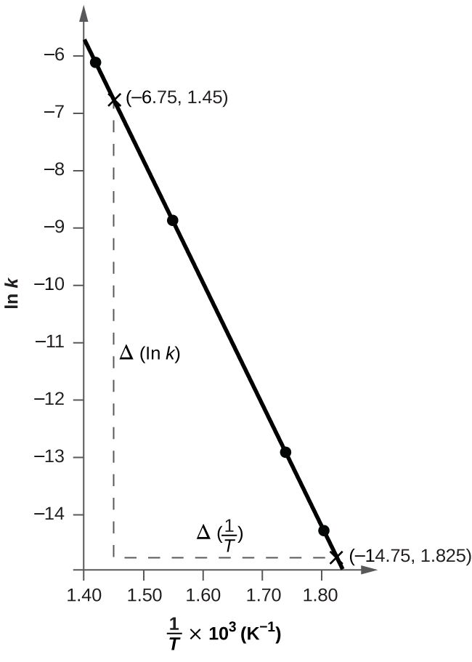



*E*a = –2.13  104  8.314 J/mol = 177 kJ/mol

65. The hydrolysis of the sugar sucrose to the sugars glucose and fructose,



follows a first-order rate equation for the disappearance of sucrose: Rate = *k*[C12H22O11]. (The products of the reaction, glucose and fructose, have the same molecular formulas but differ in the arrangement of the atoms in their molecules.)

(a) In neutral solution, *k* = 2.1  10−11 s−1 at 27 °C and 8.5  10−11 s−1 at 37 °C. Determine the activation energy, the frequency factor, and the rate constant for this equation at 47 °C (assuming the kinetics remain consistent with the Arrhenius equation at this temperature).

(b) When a solution of sucrose with an initial concentration of 0.150 *M* reaches equilibrium, the concentration of sucrose is 1.65  10−7 *M*. How long will it take the solution to reach equilibrium at 27 °C in the absence of a catalyst? Because the concentration of sucrose at equilibrium is so low, assume that the reaction is irreversible.

(c) Why does assuming that the reaction is irreversible simplify the calculation in part (b)?

Solution

(a) The text demonstrates that the value of *E*a may be determined from a plot of log *k* against  that gives a straight line whose slope is . This relationship is based on the equation  or  where . Only two data points are given, and these must determine a straight line when log *k* is plotted against 1/*T*. The values needed are:

*k*1 = 2.1  10−11

log*k*1= −10.6778

*k*2 = 8.5  10−11

log*k*2= −10.0706

*T*1 = 27 °C = 300 K

= 3.3333  10−3

*T*2 = 37 °C = 310 K

= 3.2258  10−3

The slope of the line determined by these points is given by:



*E*a = 2.303(8.314 J/mol)(–5648) = 108,100 J = 108 kJ

Whenever differences of very small numbers are taken, such as the reciprocals of *T* provided, an inherent problem occurs. To have accurate differences, a larger number of significant figures than justified by the data must be used. Thus five figures were used to obtain the value *E*a = 108 kJ. This difficulty may be alleviated by the following approach.

For only two data points, the Arrhenius equation may be used in an equally accurate, analytical solution for ­*E*a. This application is possible because the value of *A* will be the same throughout the course of the reaction. Once the value of *E*a is determined, the value of *A* may be determined from either Equation (1) or (2). Then *k* at 47 °C may be determined using the value of *E*a and *A* so determined. The procedure is as follows:



Equating the values of *A* as solved from equations (1) and (2):

 or .

Taking common logs of both sides gives:



The value of *A* may be found from either equation (1) or (2). Using equation (1):



*A* = 2.1  10–11 s–1 10+18.91 = 2.1  10–11(9.55  1018 s–1) = 2.0  108 s–1

The value of *k* at 47°C may be determined from the Arrhenius equation now that the values of *E*aand*A*have been calculated:



= 2.0  108 s–1 10–17.79 = 2.0  108 s–1(1.62  10–18) = 3.2  10–10 s–1

Using the earlier value of *E*a = 108 kJ, the calculated value of *A* is 1.3  108 s–1, and *k* = 3.1  10–10 s–1. Either answer is acceptable.

(b) Since this is a first-order reaction we can use the integrated form of the rate equation to calculate the time that it takes for a reactant to fall from an initial concentration [*A*]0 to some final concentration [*A*]:



At 27 °C.

*k* = 2.1  10−11 s−1.

In this case, the initial concentration is 0.150 *M* and the final concentration is 1.65  10–7*M*. We can now solve for the time *t*:



or 1.81  108 h or 7.6  106 day. (c) Assuming that the reaction is irreversible simplifies the calculation because we do not have to account for any reactant that, having been converted to product, returns to the original state.

67. Use the PhET Reactions & Rates interactive simulation(http://openstaxcollege.org/l/16PHETreaction) to simulate a system. On the “Single collision” tab of the simulation applet, enable the “Energy view” by clicking the “+” icon. Select the first  reaction (A is yellow, B is purple, and C is navy blue). Using the “angled shot” option, try launching the *A* atom with varying angles, but with more Total energy than the transition state. What happens when the *A* atom hits the *BC* molecule from different directions? Why?

Solution

The *A* atom has enough energy to react with BC; however, the different angles at which it bounces off of BC without reacting indicate that the orientation of the molecule is an important part of the reaction kinetics and determines whether a reaction will occur.

This resource file is copyright 2015, Rice University. All Rights Reserved.